## **AWS Assignment 9: Configure AWS CLI, SDKand Boto**

### **Configure AWS CLI**

Submit AWS CLI commands for below requirement:

1. Create a S3 Bucket

Aws s3 mb s3://awscli123

1. Deleting S3 Bucket

Aws s3 rm s3://awscli123

1. Listing contents of S3 Bucket

Aws s3 ls

1. Creating a EC2 instance

aws ec2 run-instances --image-id ami-4dd18837 --count 1 --instance-type t2.micro --key-name ravali_pem --security-group-ids sg- ravali_pem --subnet-id subnet-60838a4c

1. Copy a file from local to S3

Aws s3 cp text.txt s://awscli123

1. Create a RDS instance

aws rds create-db-instance --db-instance-identifier sg-cli-test \

--allocated-storage 20 --db-instance-class db.m1.small --engine mysql \

--master-username myawsuser --master-user-password myawsuser

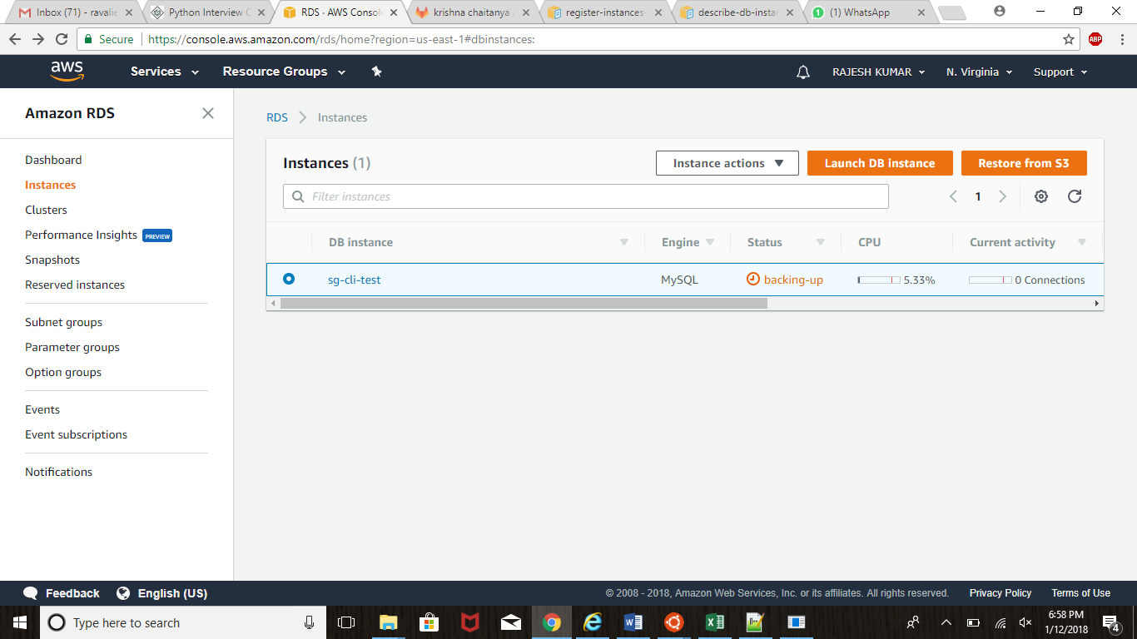

1. Creating a Snapshot for EBS and RDS.

aws ec2 create-snapshot --volume-id vol-1234567890abcdef0 --description "This is my root volume snapshot."

1. Create a IAM user

aws iam create-user --user-name Bob

1. Stop/Terminate a EC2 instance

Aws ec2 stop-instances --instance-ids ID i-0339fbf0eb57dbc80

aws ec2 terminate-instances --instance-ids ID i-0339fbf0eb57dbc80

1. Create a EC2 Classic Load Balancer

aws elb create-load-balancer --load-balancer-name my-load-balancer --listeners "Protocol=HTTP,LoadBalancerPort=80,InstanceProtocol=HTTP,InstancePort=80" --availability-zones us-east-2a us-east-2b us-east-2c

import boto.ec2

conn = boto.ec2.connect_to_region("us-west-2")

conn.run_instances(

'ami-6ac2a85a',

key_name='nitheesh_oregon',

instance_type='t1.micro',

security_groups=['nitheesh_oregon']

)

#/usr/bin/python

import boto.ec2

conn = boto.ec2.connect_to_region("us-west-2")

conn.stop_instances(instance_ids=['instance-id-1','instance-id-2'])